**Civic Engagement Survey Analysis**

Department of Statistics and Data Science

Naomi Chou(UID: 105699101), Arielle Davis(UID: 205067824), Kiana Mohammadinik(UID: 205928003), Ashish Singh(UID: 105974415), Matthew Woo(UID: 905589721)

Statistics 141XP: Statistical Consulting

Final Paper

Professor Esfandiari

Department of Statistics and Data Science

University of California, Los Angeles

United States of America

06/12/2024

**Contents**

**1. Introduction 4**

**2. Data 6**

**2.1. Variables 6**

**2.2. Pre-processing Data 6**

**2.3 EDA (Exploratory Data Analysis) 7**

**3. Analysis 13**

**3.1. Linear Mixed-Effects Model 13**

**3.1.1. Knowledge Model 13**

**3.1.2. Attitude Model 14**

**3.1.3. Behavior Model 15**

**3.1.4. Sense of Belonging Model 16**

**3.1.5. Summary of Findings 17**

**3.2. Text Mining 17**

**4. Limitations and Recommendations 25**

**4.1. Limitations 25**

**4.1.1. Limitations on Demographic Representation 25**

**4.1.2. Limitations on Survey Data 25**

**4.2. Recommendations 26**

**4.2.1. Expand Participants Demographics 26**

**4.2.2. Modifying Survey Design 26**

**5. Conclusion and Summary 27**

**Abstract**

# We explore the survey results from the UCLA Center for Community Engagement to evaluate the program's effectiveness on the students’ behavior in community engagement. To analyze the impact of the program, we compared the survey responses before and after course enrollment from the quarters of Winter 2023 and Spring 2024. Data preprocessing involved cleaning the data, handling missing values, and scaling responses to ensure consistency. By utilizing linear mixed effects models and text mining methods, we discovered significant discrepancies in the results among different student demographics, particularly between traditional and transfer students, as well as North and South Campus majors. The limitations of the study include the lack of representation for certain demographics and potential self-reporting bias. Given our findings, we recommend developing strategies to improve inclusivity and continuously updating the program to further enhance students’ civic engagement.

# **Introduction**

The UCLA Center for Community Engagement offers UCLA students the opportunity to help the local community by providing courses that increase awareness and foster a sense of civic responsibility. As a part of this program, students are asked to complete a survey before and after their classes to assist the Center in evaluating the effectiveness of the courses in specific areas: academic confidence, attitude, behavior, knowledge, and sense of belonging.

This paper primarily focuses on determining whether the results from the Winter 2024 survey differ from those of Spring 2023. In particular, we investigated changes in student’s behavior towards community engagement before and after working with their community partners. We also compared the results among different student demographics, including gender, ethnicity, major, first-generation status, and transfer student status.

To ensure the accuracy and reliability of our results, we performed exploratory data analysis to identify trends and gaps within our data set. Using that information, we then preprocessed the data to clean the survey responses, which included handling missing values, scaling the data, and simplifying labels.

For the quantitative evaluation, we employed a linear mixed effects model and clustering techniques to uncover significant differences and group behaviors among the students. These methods allowed us to account for both fixed and random effects, providing a more nuanced understanding of the data. In addition to the quantitative analysis, we performed text mining to analyze open-ended survey responses. Sentiment analysis, using the NRC and Bing lexicon, helped us gauge the emotional tone of the students' comments and further elucidate their attitudes and feelings towards community engagement.

Through this approach, our study aims to provide a comprehensive analysis of the impact of the UCLA Center for Community Engagement program on various aspects of students’ social and academic experiences.

# **Data**

## **2.1. Variables**

Our initial dataset had a total of 844 observations (after pooling both Winter 2024 and Spring 2023 surveys) and 33 predictors to analyze. Predictors consisted of various identifiers such as timestamp, as well as, questionnaires suited for categorical responses on a Likert scale of magnitude from 1 to 5, categorical demographic options, and free response. More specifically, the free response allowed subjects to write their own textual answer to a question. Frequency was the main form of measurement outside of the free response questions. Given all this information, we narrowed down our scope of interest with data cleaning.

## **2.2. Pre-processing Data**

Our data cleaning process began by combining the “Pre” and “Post” datasets from both Winter 2024 and Spring 2023 so that we could aggregate our analyses and increase our overall sample size. Additionally, inessential columns such as timestamp, date of survey, last name, minor, extra elaboration on gender identity, and name of the community partner organization were removed. Variable columns were then renamed for easier interpretation, for example, an entire question would be abbreviated to “Q1” and so on. Responses missing key information were fleshed out using median response values and duplicated observations were removed, resulting in a remaining 560 observations.

A particular challenge was simplifying the “Course” variable which contained multiple unique text responses displaying the same civic engagement courses in a myriad of different ways. In order to address this, our team had to sift through all the responses by hand to find the different titles that represented the same course. We chose to assign a new label, like "CCAS100XP," to all of its variations, such as "23S-CCAS 100XP", "CCAS 100XP", and more. This method was repeated for all of the civic engagement course offerings noted in the survey. Our team spent the time engaging in this preparatory work to better illustrate the impact of certain courses in relation to others when evaluating student opinion.

Some additional modifications include altering the “Ethnicity” variable into a factor with multiple levels and creating our own categories for majors located in North and South Campus. These allowed us to answer our client’s original research questions about demographic relationships with ease.

Finally, some survey questions were structured on a Likert scale that was reversed in comparison to others. For instance, 1 may represent the most positive answer and 5 the most negative, when typically survey construction relies on the opposite approach. To ensure responses all followed the same scale, such inverted questions were adjusted for clear comparison.

## **2.3 EDA (Exploratory Data Analysis)**

The following is a representation of gain by various demographics of interest, in other words, the decrease or increase in student opinion measured in frequency.. Assessing the difference in responses between the “Pre” and “Post” surveys provided a clear synopsis from which we could draw conclusions. Our EDA emphasized a demographic investigation of these aspects: Gender, Ethnicity, Major, First Generation Status, and Transfer Status. Gain was evaluated in a series of clusters, or “buckets” of questions that were highly correlated and generally related to a central topic. The clusters that encapsulated such questions were given the labels: Academic Confidence, Attitude, Behavior, Knowledge, and Sense of Belonging.

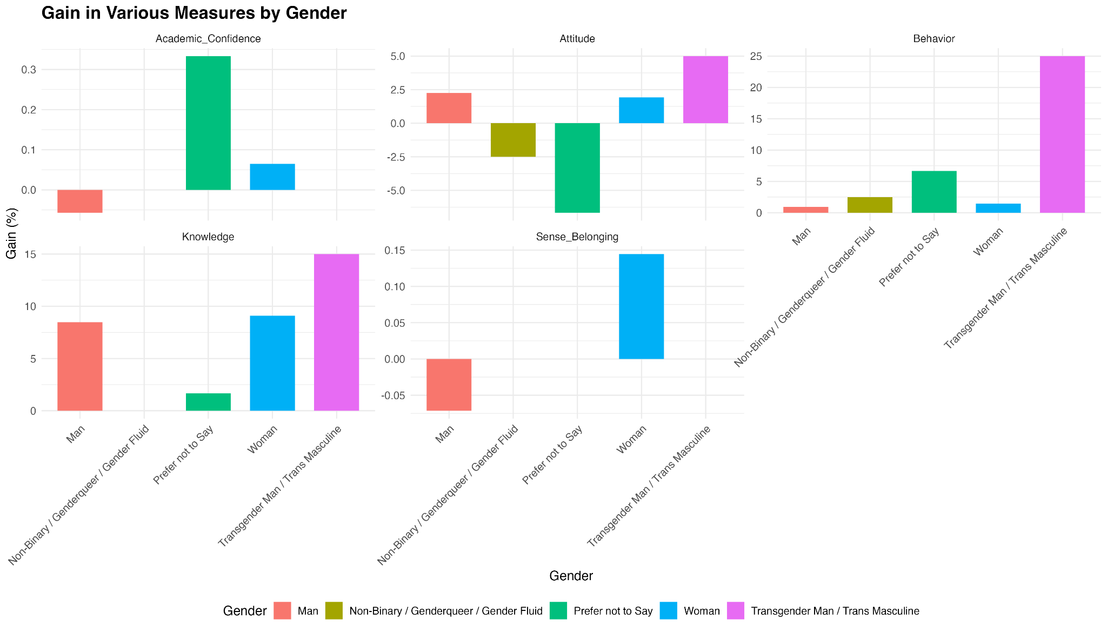

In this figure, Transgender Men/Trans Masculine individuals show the highest gains in knowledge and behavior, while women exhibit significant improvements in academic confidence and knowledge. Additionally, there are notable variations in sense of belonging and attitudes across different gender identities, highlighting the diverse impacts of our programming.

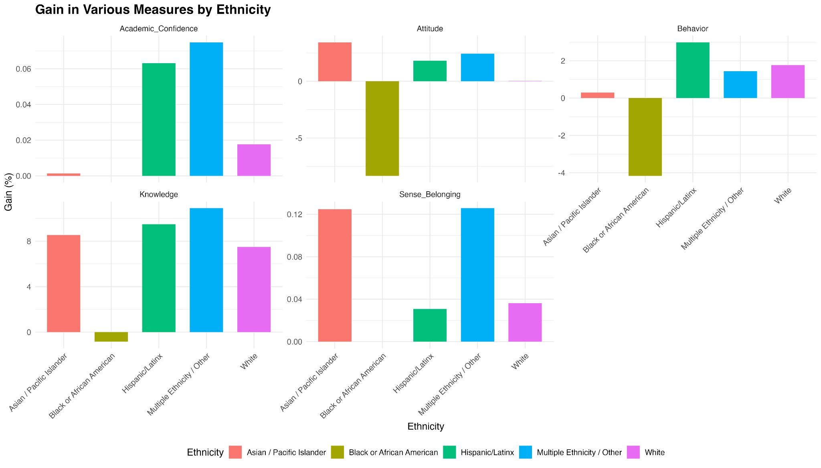

The figure above displays gains in various measures by ethnicity. Multiple Ethnicity/Other and Hispanic/Latinx groups show significant gains in knowledge, while Black or African American students exhibit a notable decrease in sense of belonging and attitudes. The graph illustrates the diverse impact across ethnic groups, with White and Hispanic/Latinx students showing positive gains in several areas.

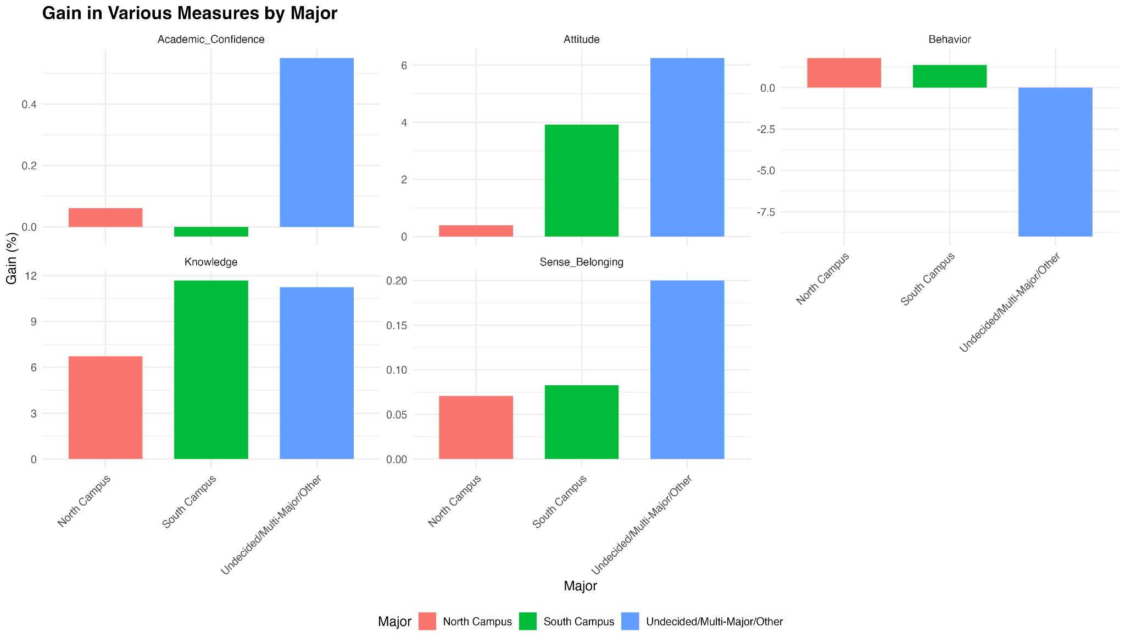

This graph highlights the gains in various measures by major. South Campus and Undecided/Multi-Major/Other students exhibit significant gains in knowledge, with the latter also showing high improvements in academic confidence and attitude. However, Undecided/Multi-Major/Other students experienced a decrease in behavior scores, indicating varied impacts of the programming across different major groups.

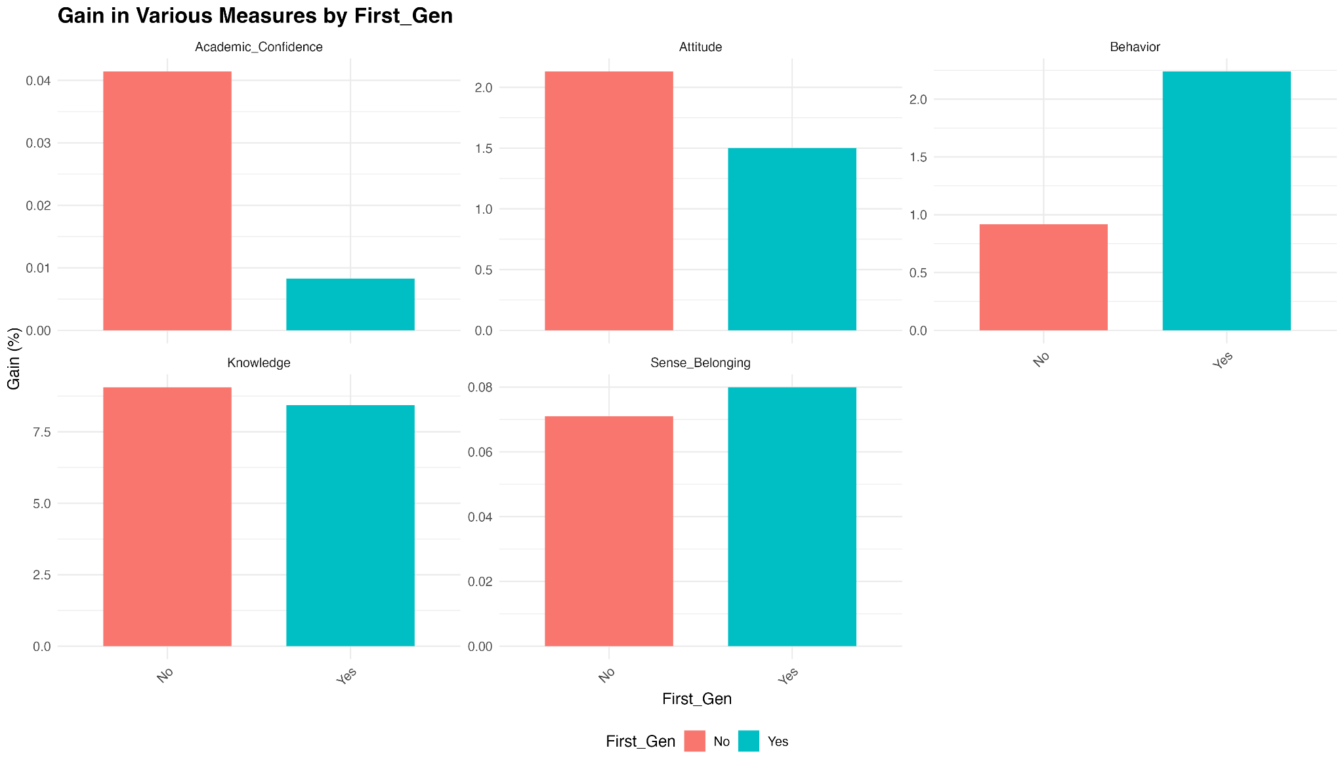

This graph illustrates various measures by first-generation status. First-generation students show higher gains in behavior compared to non-first-generation students. While both groups exhibit similar improvements in knowledge and sense of belonging, non-first-generation students show a slightly higher increase in academic confidence and attitude, highlighting the positive impact of the programming on diverse student backgrounds.

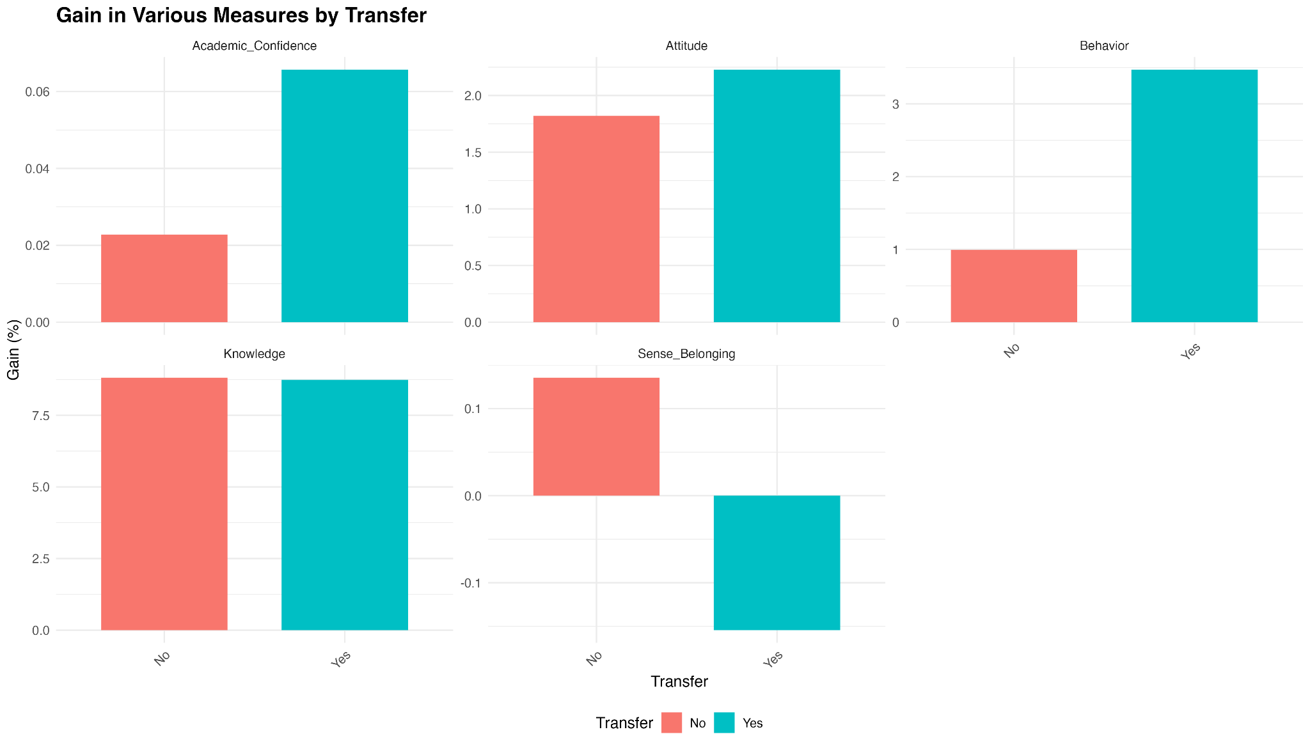

This final chart showcases gains in various measures by transfer status. Transfer students exhibit higher gains in academic confidence, attitude, and behavior compared to non-transfer students. Both groups show similar improvements in knowledge, while non-transfer students have a slightly higher sense of belonging. These results highlight the positive impact of the programming on transfer students, enhancing their academic and behavioral outcomes.

# **Analysis**

## **3.1. Linear Mixed-Effects Model**

### **3.1.1. Knowledge Model**

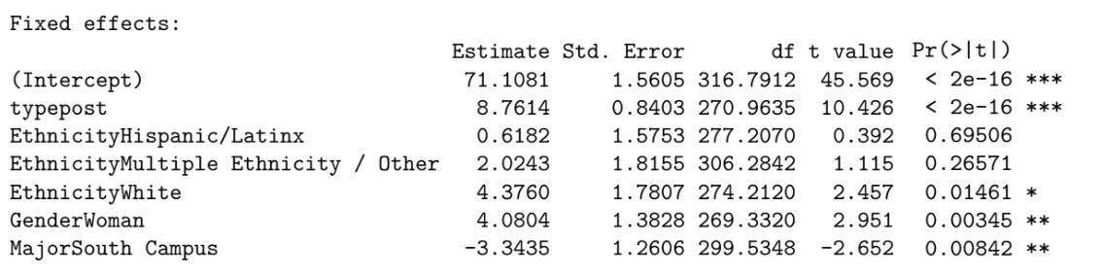

The analysis reveals that post-class scores are significantly higher than pre-class scores by an average of 8.76 points. This indicates that there is a statistically significant improvement in knowledge following the class, which means that the class had a positive impact on the students’ knowledge on community engagement.

The analysis of the impact of ethnicity on knowledge scores, with the baseline being likely Asian/Pacific Islander, shows varied results:

* Hispanic/Latinx: Not significantly different (p = 0.695).
* Multiple Ethnicity / Other: Not significantly different (p = 0.266).
* White: Significantly higher by 4.38 points (p = 0.015).

The results above suggest that white students, on average, had a statistically significant better understanding of community engagement after taking the course. Gender differences in knowledge scores indicate that women have significantly higher scores than men by 4.08 points. In addition, students from South Campus have significantly lower scores by approximately 3.34 points.

In summary, while post-class scores improved overall, white students, women, and North Campus majors (primarily humanities students) showed higher scores compared to other demographics.

**Random Effects:**

* Variance for Intercept (Subject): 55.55
* Standard Deviation for Intercept (Subject): 7.453

**Interpretation:** The significant variability between subjects (as reflected in the substantial standard deviation) indicates differing baseline levels of knowledge about community engagement.

### **3.1.2. Attitude Model**

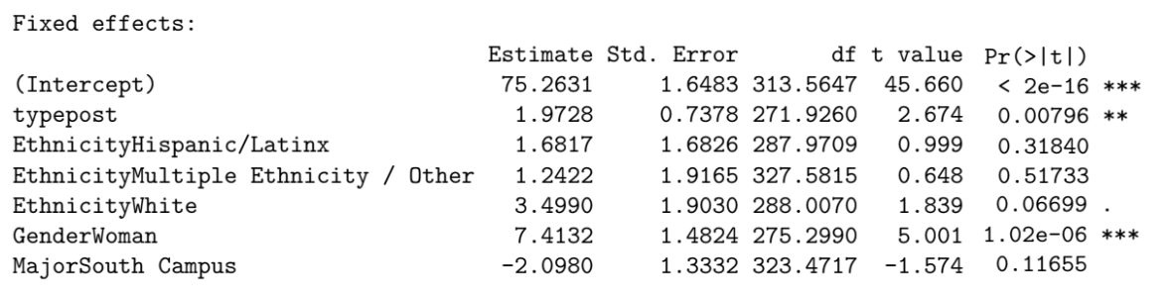

The analysis reveals that post class scores are higher by an average of 1.97 points, with a p-value of 0.008. This statistically significant value suggests that the class had a positive influence on the students’ attitudes towards civic engagement.

Our analysis shows that differences based on ethnicity and campus major are not statistically significant, indicating that these factors do not have a meaningful impact on attitude scores. Nevertheless, women have higher scores than men by 7.41 points. This suggests that women, on average, have more positive attitudes towards civic engagement compared to men. These findings highlight the importance of considering gender in educational outcomes related to attitudes and may inform targeted interventions to address disparities and enhance educational experiences.

**Random Effects:**

* Variance for Intercept (Subject): 82.78
* Standard Deviation for Intercept (Subject): 9.098

**Interpretation:** The high variance among individuals shows the variability attitudes towards community engagement prior to the intervention.

### **3.1.3. Behavior Model**

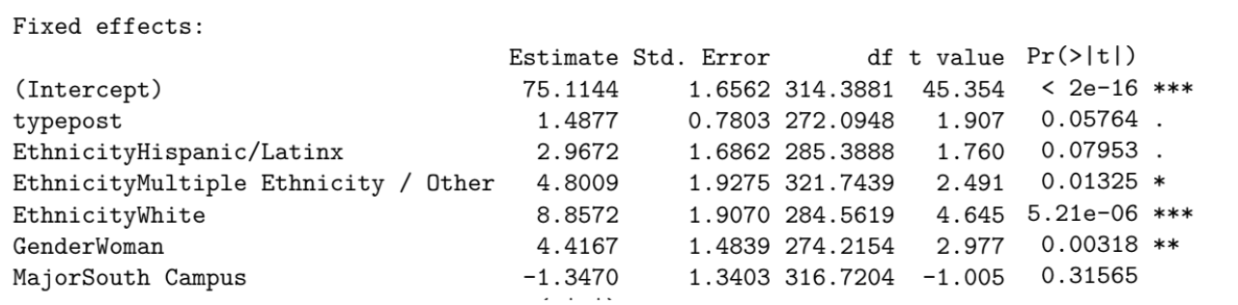

This model reveals that the post class scores are marginally higher by 1.49 points, with a p-value of 0.058. This suggests a slight improvement in behavior scores following the class, even though it is not statistically significant.

Our analysis demonstrates that compared to the baseline of Asian/Pacific Islander scores, each ethnicity had varied results:

* Hispanic/Latinx: Marginally higher by 2.97 points (p = 0.080). This suggests that though there is a trend for higher scores, the results are not statistically significant.
* Multiple Ethnicity / Other: Significantly higher by 4.80 points (p = 0.013).
* White: Significantly higher by 8.86 points (p = 5.21e − 06).

Similar to the previous models, women have significantly higher scores by 4.42 points (p = 0.003), indicating that they exhibit more positive behavior compared to men after taking the class. There is no significant difference in scores between North and South Campus majors, suggesting that the field of study has no impact on behavior in this context.

**Random Effects (ID):**

* Variance for Intercept (Subject): 78.44
* Standard Deviation for Intercept (Subject): 8.856

**Interpretation:** There is considerable subject variability in initial behaviors related to civic engagement.

### **3.1.4. Sense of Belonging Model**

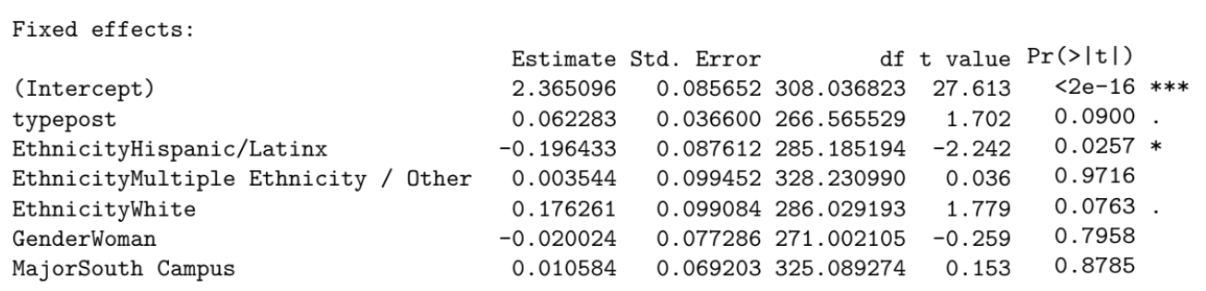

The analysis reveals that the post-class scores are marginally higher by 0.06 points with a p-value of 0.09, indicating that it is not statistically significant. This suggests a slight improvement in the sense of belonging following the class. The impact of ethnicity on sense of belonging had varied results:

* Hispanic/Latinx: Significantly lower by 0.20 points (p = 0.026). This statistically significant decrease indicates that Hispanic/Latinx students, on average, feel a lower sense of belonging compared to their Asian/Pacific Islander peers. This result suggests that there may be specific factors affecting the sense of belonging for Hispanic/Latinx students that need to be addressed.
* Multiple Ethnicity / Other: Not significantly different (p = 0.972). This lack of a significant difference suggests that these students do not experience a different sense of belonging within the community.
* White: Marginally higher by 0.18 points (p = 0.076). Though the results are not statistically significant, this marginal increase suggests that White students may feel more comfortable within the educational setting compared to other peers. Further research might explore if there are subtle factors contributing to this trend and if it could reach statistical significance with a larger sample size.

Moreover, gender and campus major differences do not significantly impact the sense of belonging score. These findings highlight the importance of considering ethnicity in educational outcomes related to the sense of belonging and may find other ways to enhance the sense of belonging across diverse student populations.

**Random Effects (ID):**

* Variance for Intercept (Subject): 0.2349
* Standard Deviation for Intercept (Subject): 0.4847

**Interpretation:** Compared to other models, the lower variance in the sense of belonging model suggests more uniformity among students’ feelings of belonging at baseline.

### **3.1.5. Summary of Findings**

1. The civics study class has a marginally positive effect on Attitude, and Behavior scores, but the reported gains are particularly significant for Knowledge.
2. Gender differences are notable, with women showing higher improvements across Knowledge, Attitude, and Behavior.
3. Ethnicity differences suggest that White students reported more in gain of Knowledge and Behavior, while Hispanic/Latinx students show a decrease in Sense of Belonging.
4. South vs North campus didn’t have much of a significant effect on any category except for “Knowledge” gain for which students from South Campus have reported significantly lower scores than students from the North Campus.

## **3.2. Text Mining**

We utilized RStudio to use text mining techniques for sentiment analysis and generate sentimental plots. First, the textual data was cleaned and preprocessed to eliminate stop words, punctuation, and extraneous characters. By taking this step, the text was prepared for analysis. Tokenizing the cleaned text was the next step, which required dividing the text into smaller units, usually words, to make the analysis that followed easier. We conducted sentiment analysis using the tidytext package, giving words sentiment scores by using prepackaged lexicons such as NRC and Bing. A sentiment score from the lexicon corresponded to each word in the tokenized text. To get an overall sentiment score, the sentiment scores were then combined at various levels, such as by pre/post survey, North/South major, traditional/transfer admission, course taken, old/new survey, and by each survey individually. We visualized the sentiment scores using bar plots made with the ggplot2 package. The percentages of positive, negative, and neutral attitudes were shown in these plots, which illustrated the sentiment distribution. We compared sentiment scores to examine changes over time or across different groups. Plots were generated and images were saved for further reporting and presentation. While we developed sentiment plots for the pre and post surveys by course, we ultimately chose not to expand on those plots as they were not as informative, however, we have saved them for future use if needed. We also chose to leave out the undecided major plots as the sample size was very small and could lead to poor results, however, we still developed and saved the plots to have them in our files. This methodology offered an efficient and well-organized way to carry out sentiment analysis.

When developing plots with the NRC and Bing sentiments, we found that the Bing sentiment plots were not as informative. Plots such as the ones below are some of the Bing plots developed.

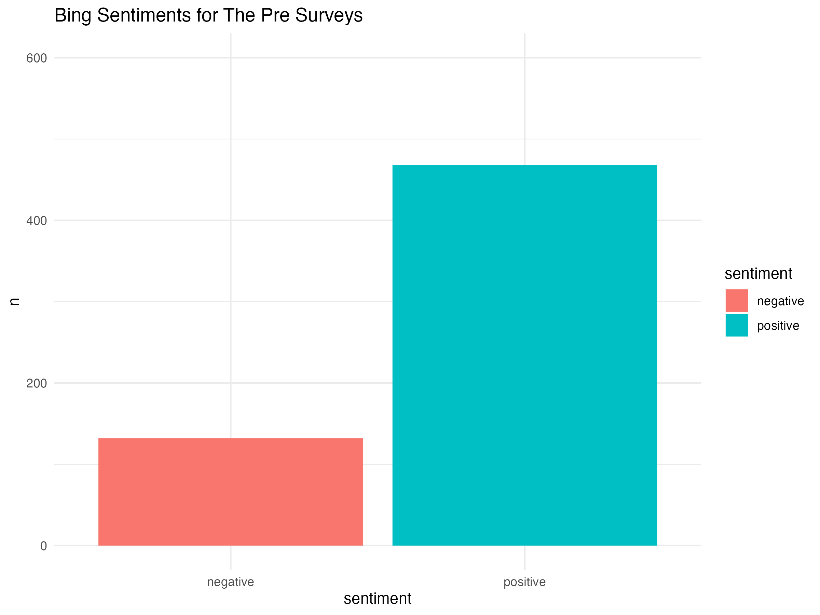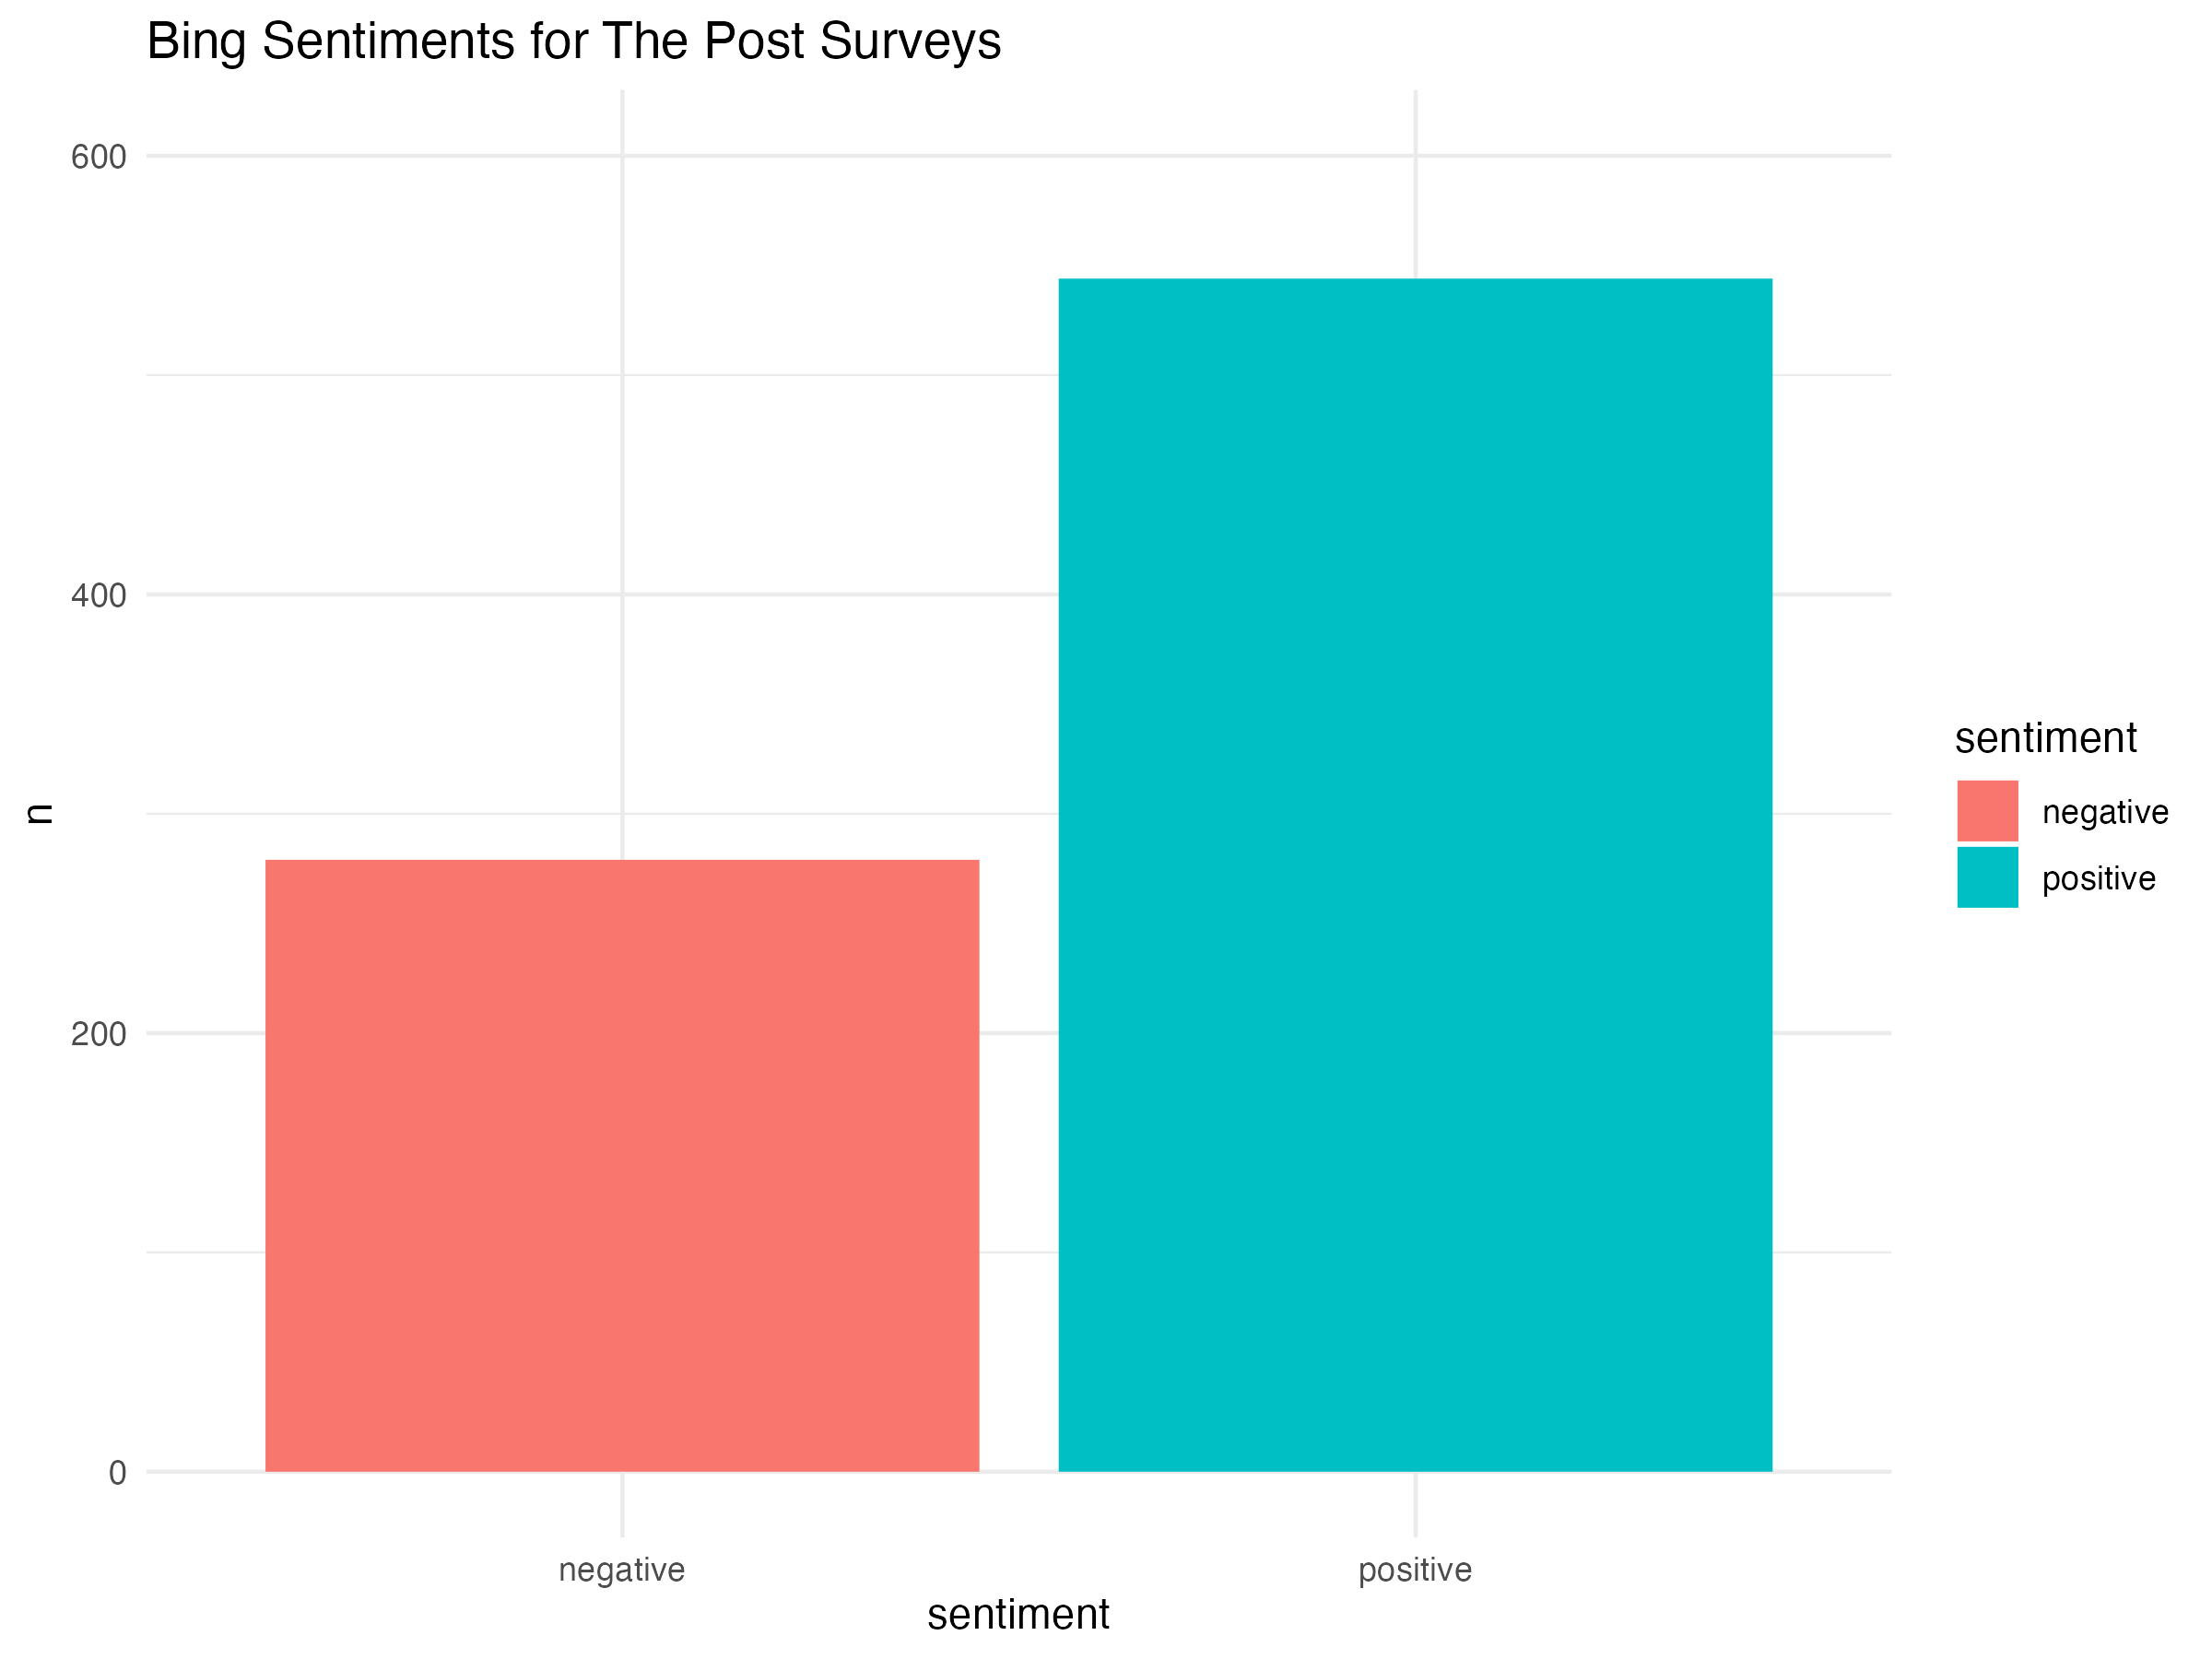

[**Figure 1]** Bing Sentiments for Pre Surveys [**Figure 2**]Bing Sentiments for Post Surveys

While the difference between [**Figure 1**] and [**figure 2**] show a slight increase in negativity, they also show an increase in positivity showing that the proportion is very similar between the pre and post surveys. Many of the Bing plots followed similar patterns or results allowing us to conclude that the plots would not be as informative as we perceived. Although we did not find the plots very informative, we still followed through with the process for all of the comparisons in case the plots may be found useful to another.

When analyzing the plots, we found the comparison between old and new surveys as the important one to begin with. Below you can see how the plots compare and contrast.

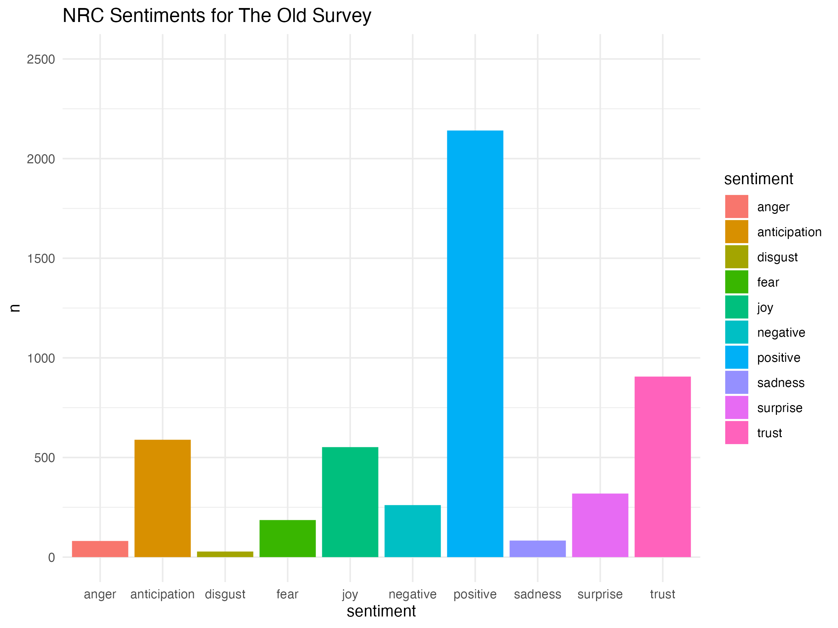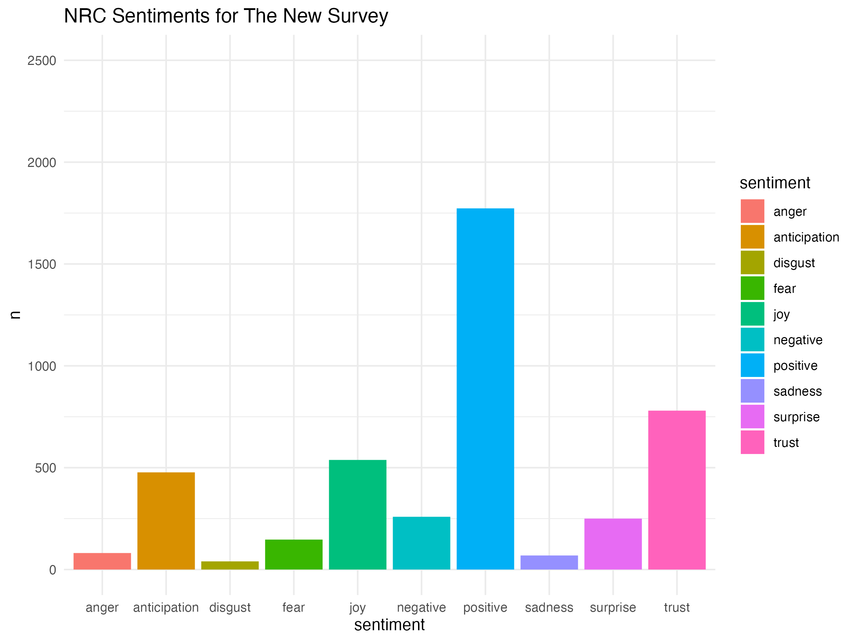

[**Figure 3]** NRC Sentiments for Old Surveys [**Figure 4**]NRC Sentiments for New Surveys

When viewing these [**Figure 3**] and [**Figure 4**], we found that both plots follow a similar, if not the same pattern allowing us to conclude that there are no significant differences between the old quarter sentiments and the new quarter sentiments. This is important to note because when following through with other comparisons, we will not have to worry about the time when surveys were taken as a factor in our analysis.

Continuing on, we compared the pre surveys to the post surveys in order to identify how students felt coming into the course and how they felt after completing the course. Below are the sentiments for the pre and post surveys.

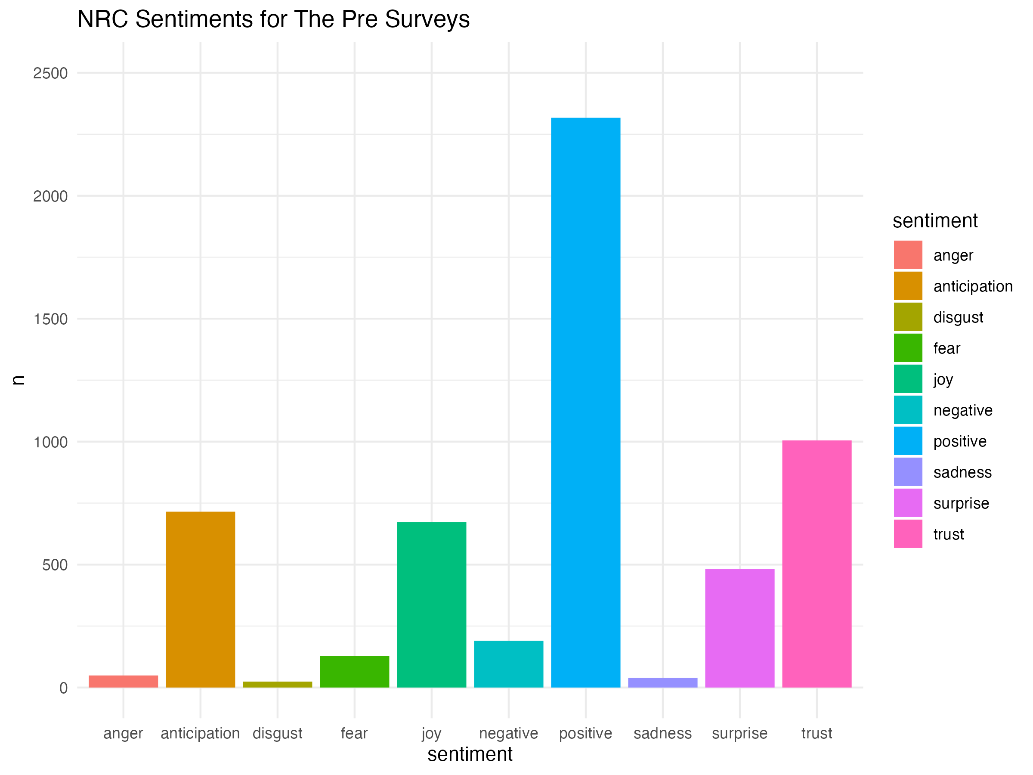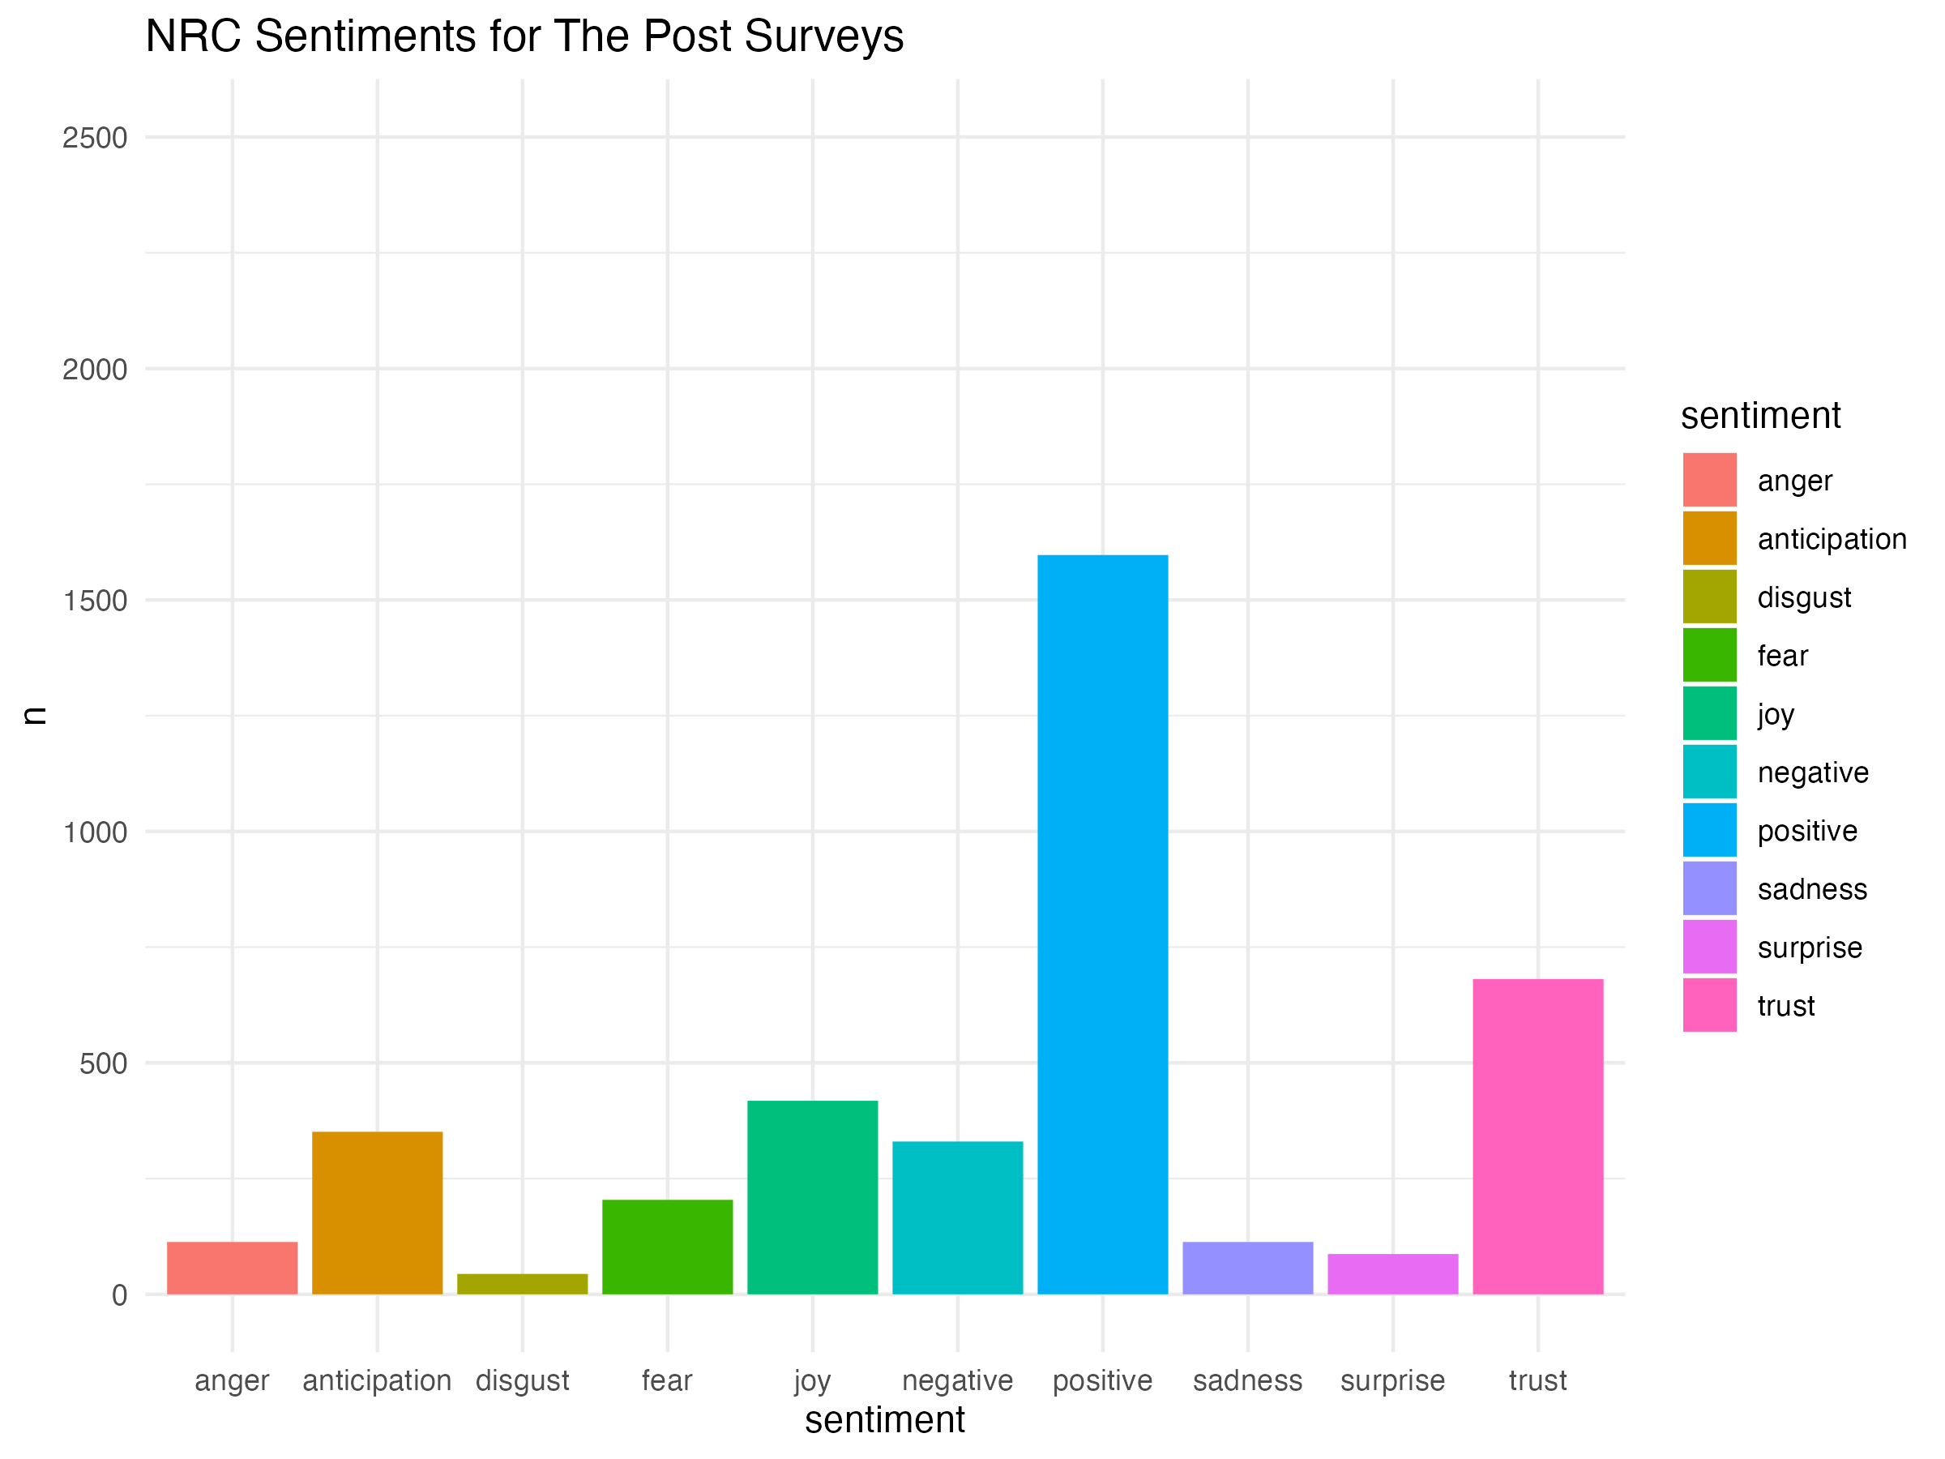

[**Figure 5]** NRC Sentiments for Pre Surveys [**Figure 6**]NRC Sentiments for Post Surveys

From [**Figure 5**] and [**Figure 6**], we conclude that not much changes when the students enter the course and when they are almost done with the course. This indicates that student expectations are generally met throughout the course. One change in the figures that may be notable would be the change in surprise before and after taking the course, however, the surprise sentiment is not notable since it is going down signifying positive change after taking the course. Since the pre and post surveys show no significant changes, it created an unbiased foundation that we used as standard for the future comparisons.

After developing a standard for the sentiment plots, we decided to continue further by comparing the traditional student sentiments to the transfer student sentiments. Following are the pre survey sentiments from both the traditional and the transfer students.

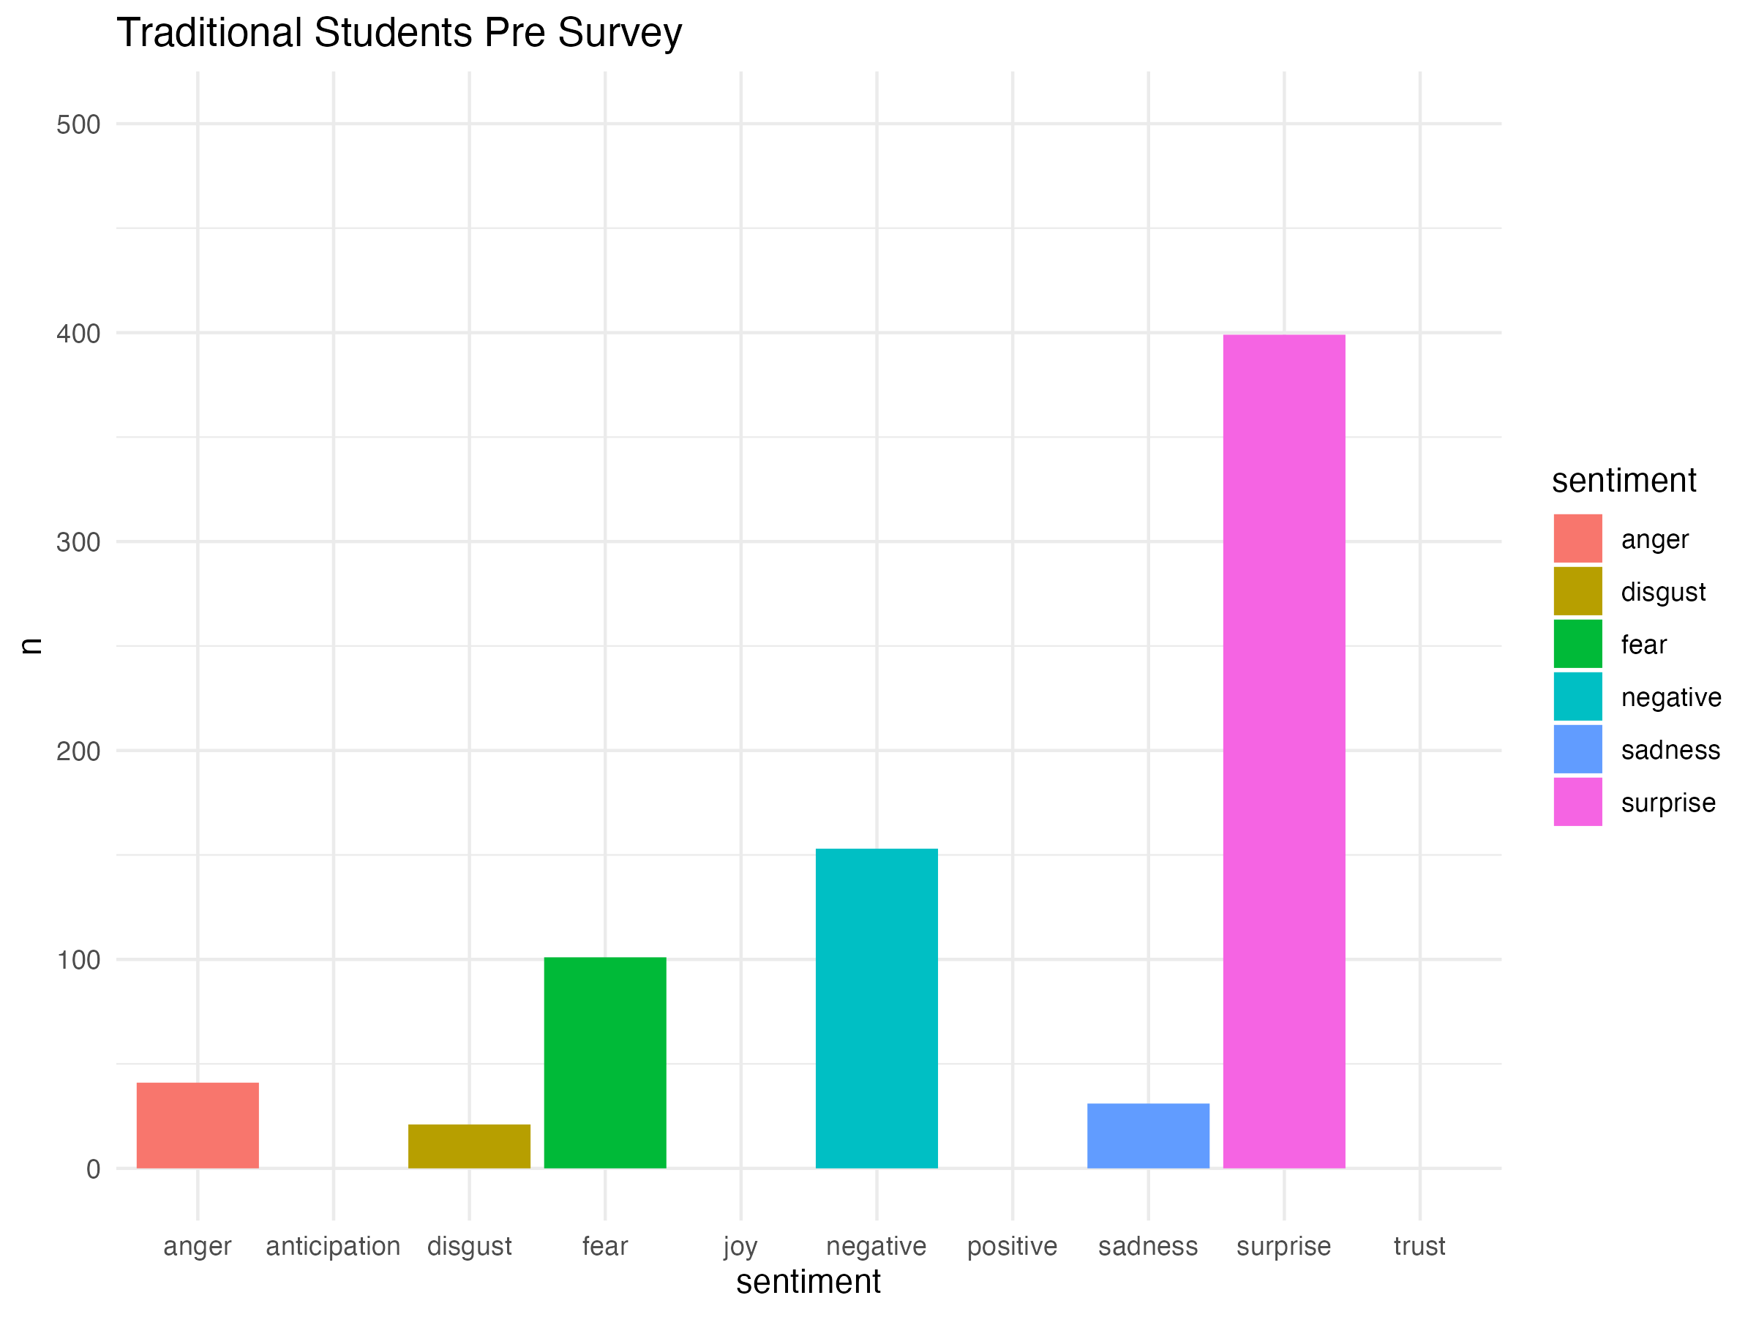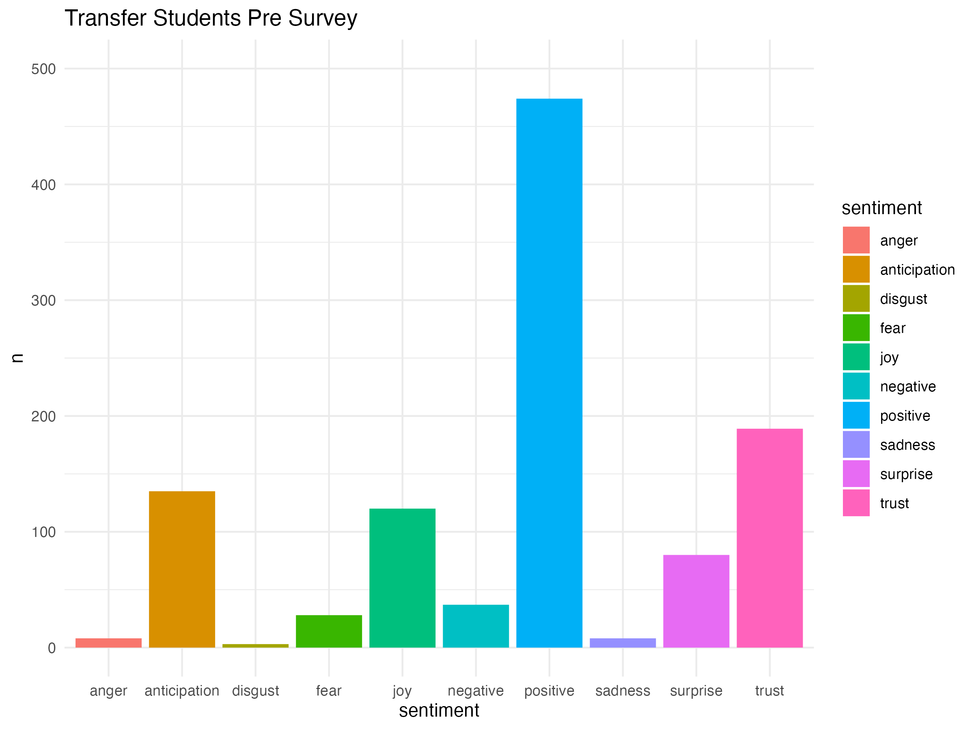

[**Figure 7]** NRC Sentiments for Traditional Students Pre Surveys

[**Figure 8**]NRC Sentiments for Transfer Students Pre Surveys

From [**Figure 7**] and [**Figure 8**] we notice significant differences in the sentiments between the traditional and transfer students when beginning the civics courses. In [**Figure 7**] we see how traditional students do not come into the course with any positivity, joy, nor trust which is fairly opposite of transfer students as seen in [**Figure 8**]. This is interesting to see because it shows us how transfer students come into the civics courses with positive engagement in respect to traditional students. After identifying these differences, we continued along with this comparison by checking on the post survey results as provided below.

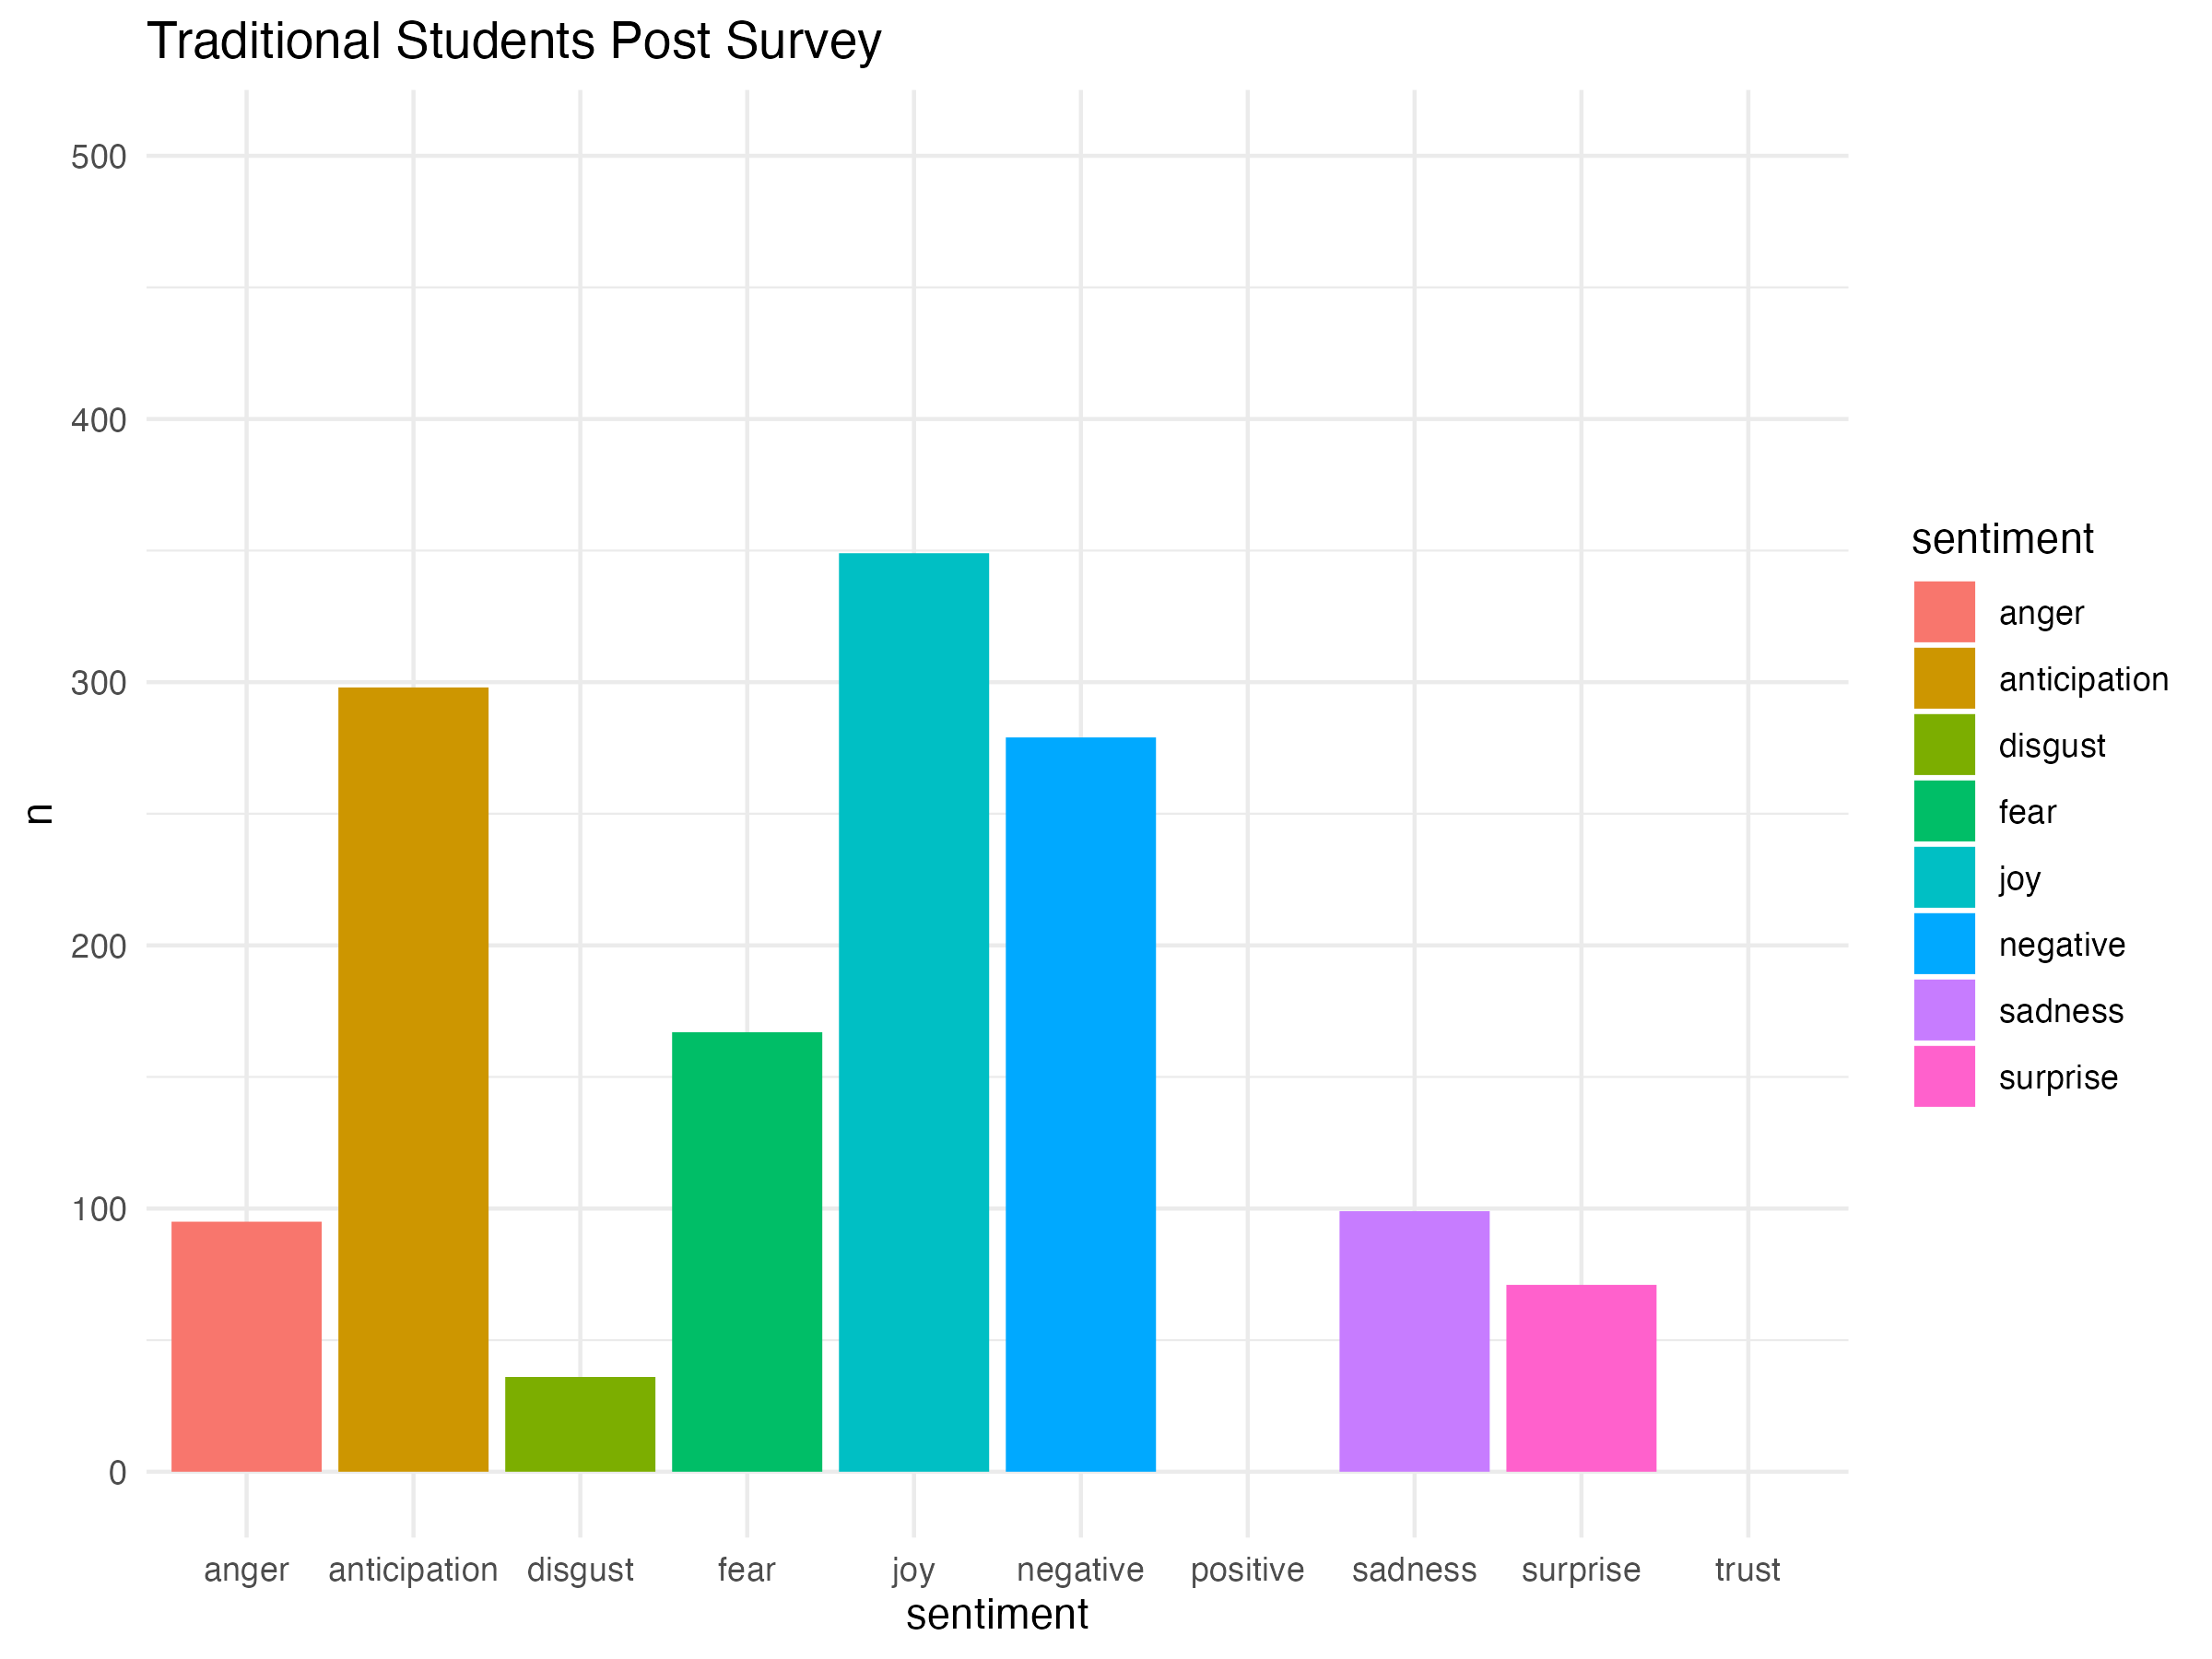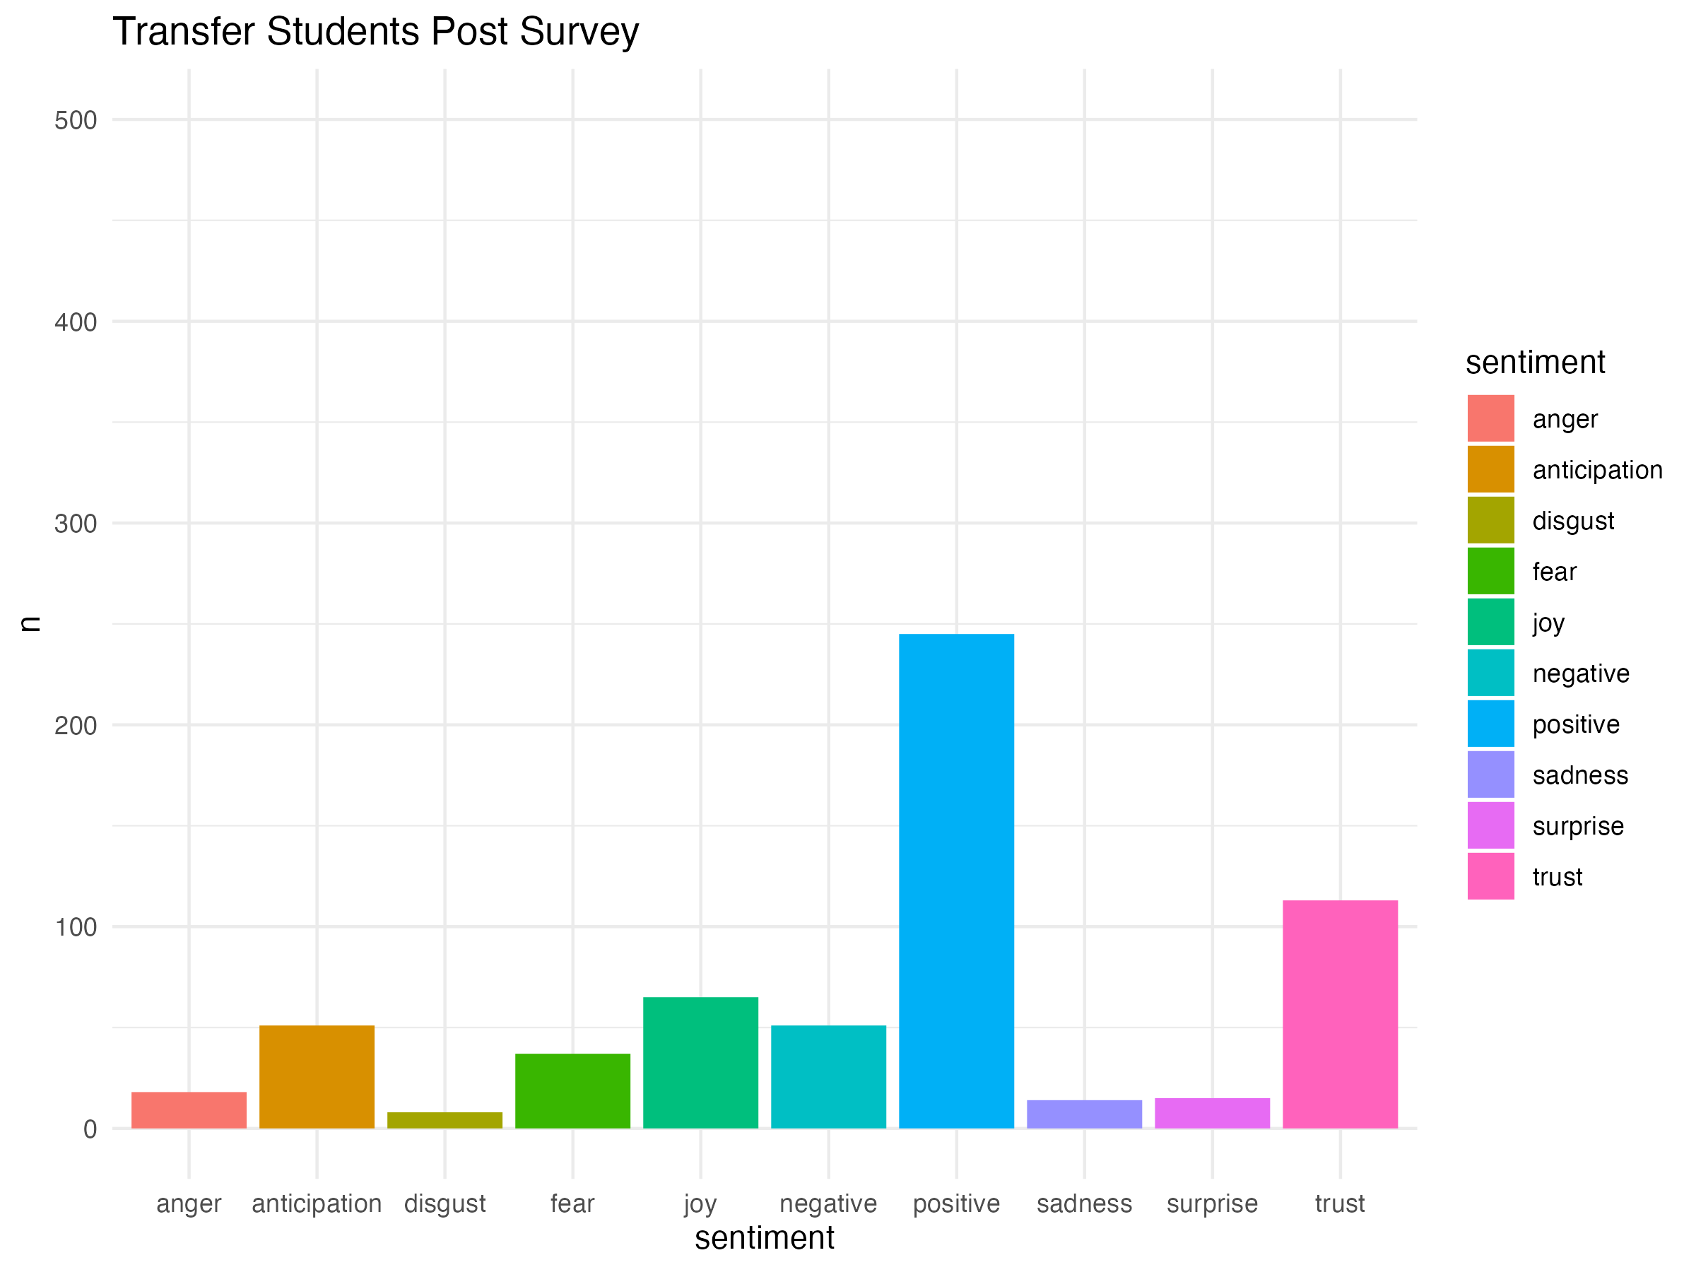

[**Figure 9]** NRC Sentiments for Traditional Students Post Surveys

[**Figure 10**]NRC Sentiments for Transfer Students Post Surveys

From [**Figures 9**] and [**Figure 10**], we see key differences between the sentiments joy, positive, negative, trust, and anticipation. While the traditional students are not as positive about the civics courses, they still seem to have enjoyed the civics courses. The transfer students show opposite sentiments by having low joy and high positivity. Based on those results, we would conclude that the traditional students are more negative in their sentiments because they are more professional when taking these civics courses thus showing why they still enjoy the civics courses. This would also tie in with the difference between anticipation levels indicating that traditional students are likely excited about future courses while transfer students most likely do not feel the same way. Being able to draw certain conclusions with this comparison allows us to further our research by examining other comparisons.

We finished off our sentimental analysis by comparing the differences in sentiments between the north and south campus majors. Following our pre and post standard, we began by comparing the pre sentiments as provided below. 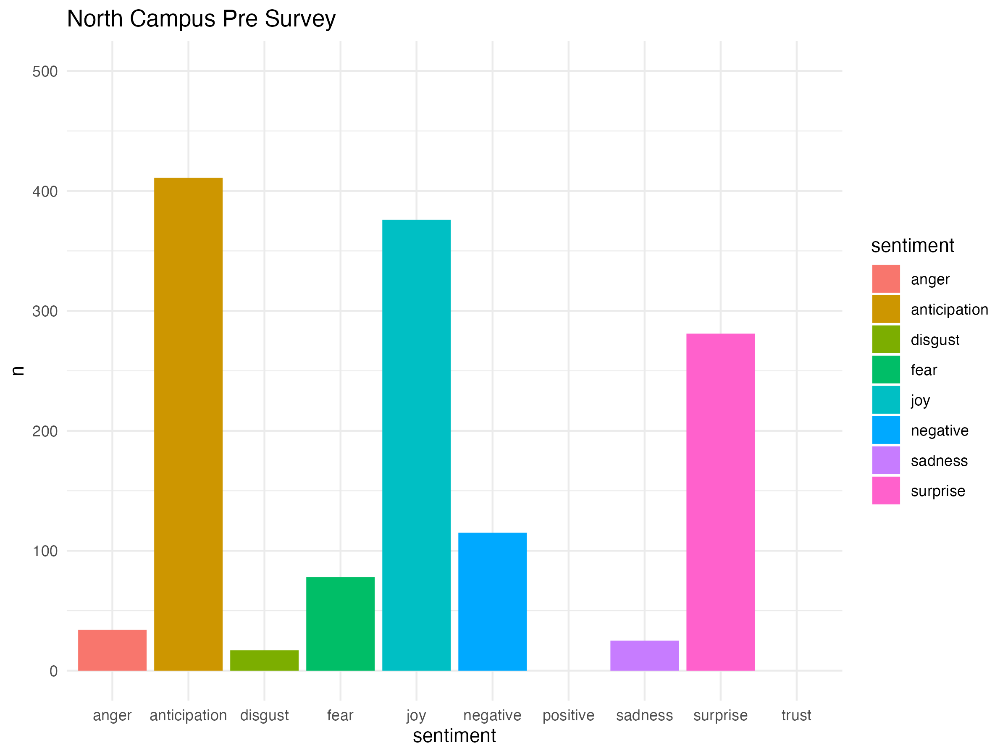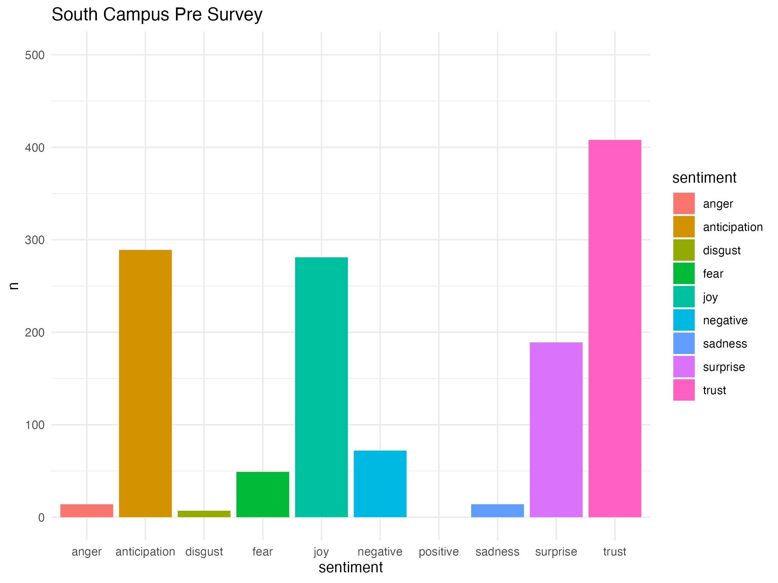

[**Figure 11]** NRC Sentiments for North-Campus Major Pre Surveys

[**Figure 12**]NRC Sentiments for South-Campus Major Pre Surveys

Observing [**Figure 11**] and [**Figure 12**], We find an important difference in the trust sentiment. From the differences in the trust sentiments, we understand that south campus majors are more comfortable when beginning the civics courses while north campus majors are not. For these plots, it was interesting to see that both groups were not very positive or negative towards taking the course while also maintaining high anticipation and joy. We agreed that this would be due to the idea of professionality since the students from both groups are enjoying the civics courses without showing any strong emotions towards the civics courses. To wrap up our findings with the north campus majors compared with the south campus majors, we analyzed the post survey results below.

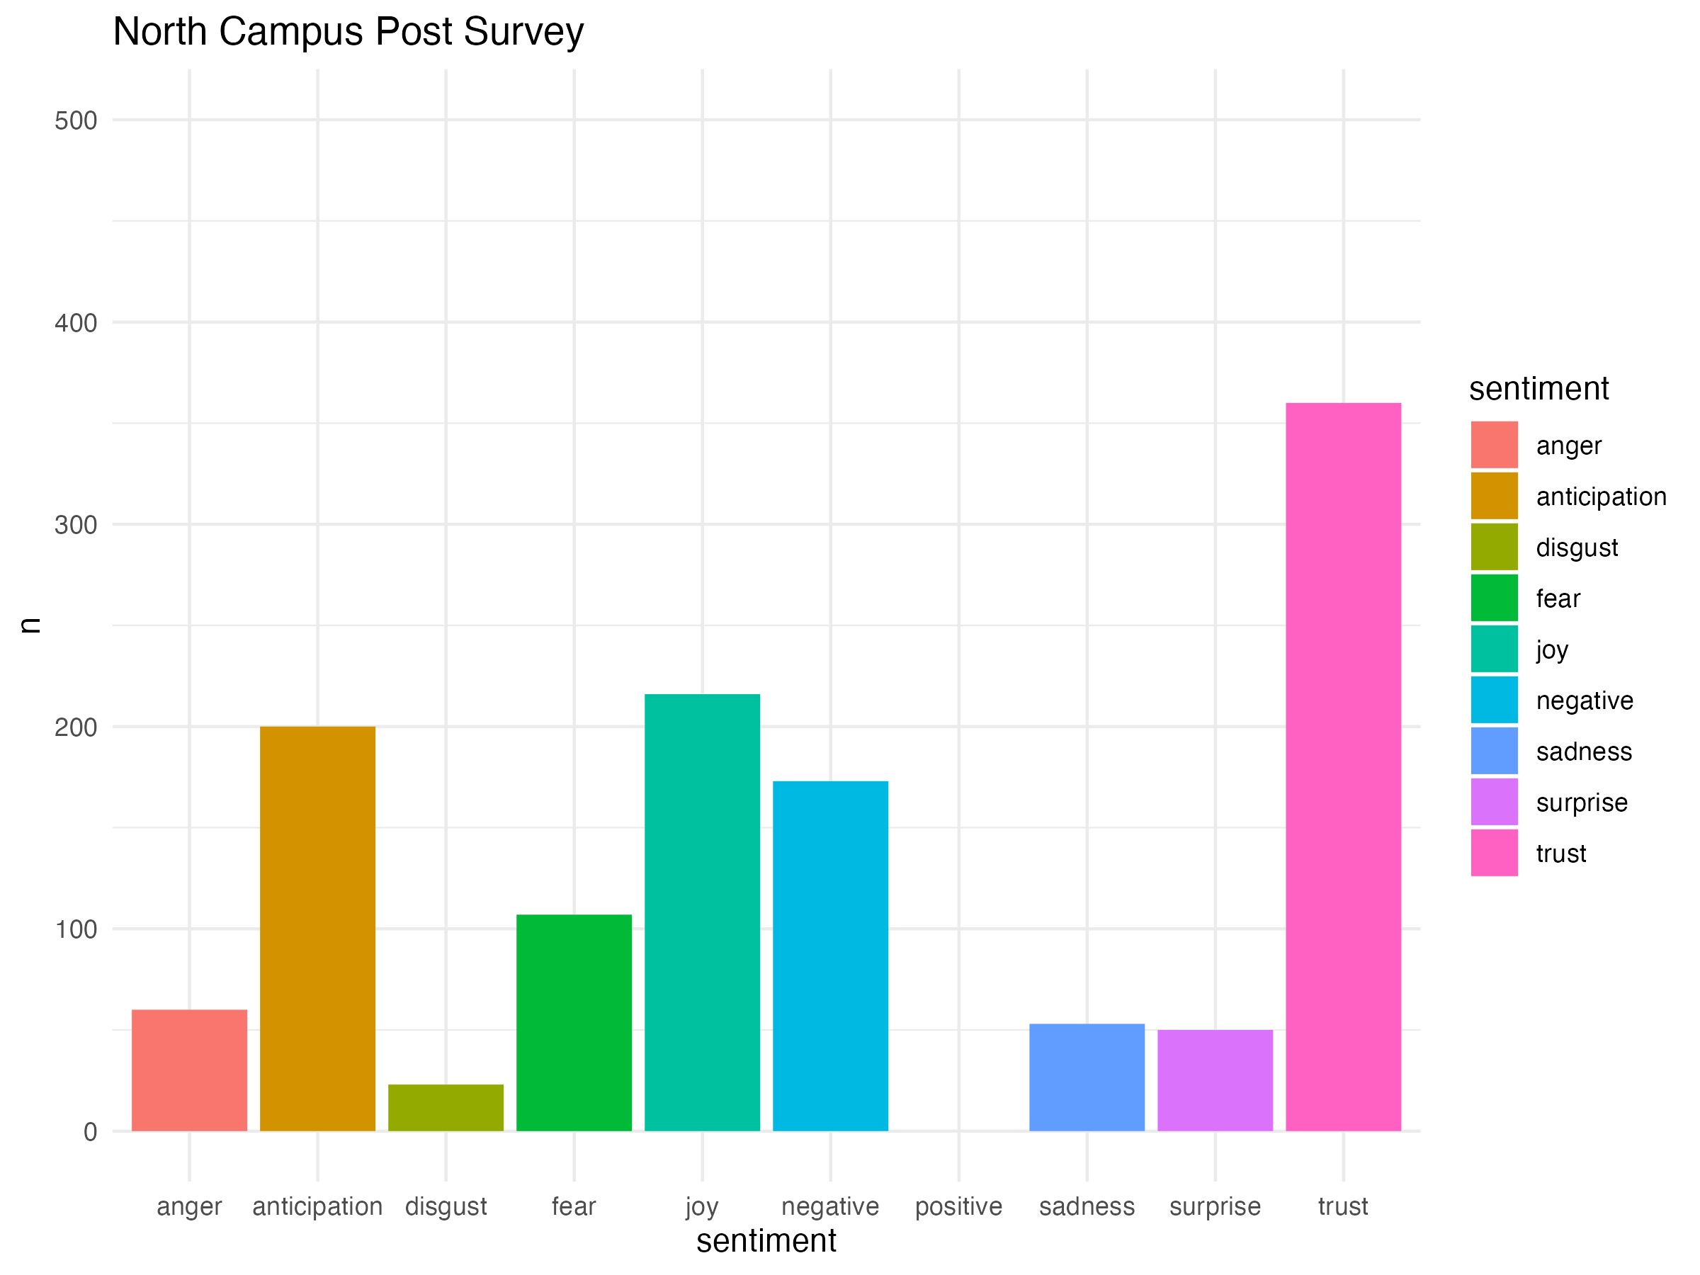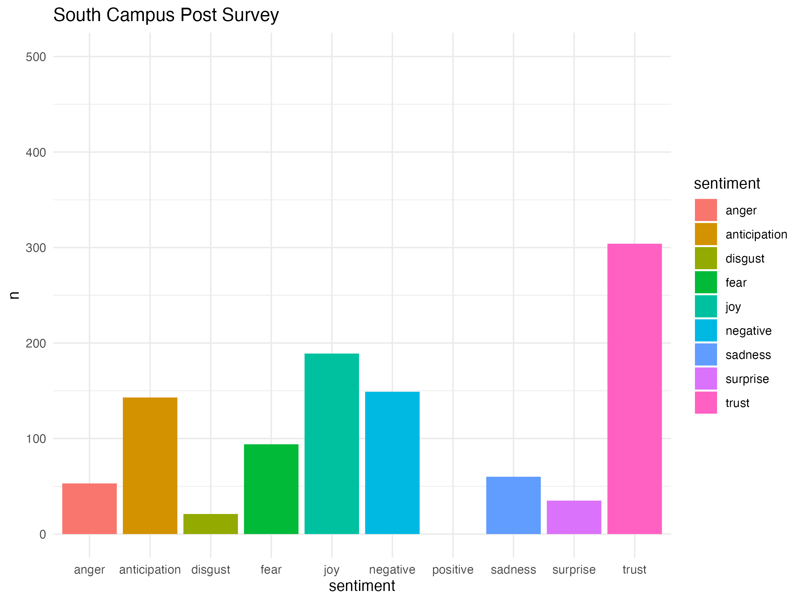

[**Figure 13]** NRC Sentiments for North-Campus Major Post Surveys

[**Figure 14**]NRC Sentiments for South-Campus Major Post Surveys

Interestingly, [**Figured 13**] and [**Figure 14**] show a shift in the sentiments that practically align the sentiments from both groups. While there are slight changes in the plots, they are not significant enough to draw differences between the north campus majors and the south campus majors. We found that the shift in sentiments producing almost identical results from the figures is a sign of positive engagement between the north campus majors and the south campus majors. This is important to note because it shows positive effects from the civics courses towards the student population.

# **Limitations and Recommendations**

## **4.1. Limitations**

### **4.1.1. Limitations on Demographic Representation**

1. **Underrepresentation for Minority Groups:** The sample size for certain minority groups were too small to analyze independently. For example, there were only 12 African Americans in the whole dataset of 560 observations. We chose to combine them with the other/multiple ethnicity category. A similar situation occurred with certain gender minorities.
2. **Combining Categories:** When creating a linear mixed-effects model, the granularity of the results can be reduced by combining specific categories (e.g., ethnicity and gender) for a thorough analysis.

### **4.1.2. Limitations on Survey Data**

1. **Response Bias:** Relying on self-reported data introduces the possibility of response bias and social desirable bias. Participants may provide answers that they perceive as favorable rather than reflecting their true attitudes and behaviors. For example, subjects may identify desirable responses and choose them over answers that reflect their true feelings.
2. **Recall Bias:** The accuracy of pre-course evaluations may be distorted by participants' recollections of pre-course attitudes and actions, which may be impacted by their current experiences and perspectives.

## **4.2. Recommendations**

### **4.2.1. Expand Participants Demographics**

* 1. **Diversify the Samples:** To increase the robustness of our analysis and the generalizability of our findings, we must ensure a more balanced representation of different races, genders, and backgrounds. To maintain a balance for the underrepresented groups, targeted outreach could help for a logical analysis in the overall study.
  2. **Comprehensive analysis of Subgroups:** To better understand the specific needs of different demographic subgroups, understanding their unique and diversified experiences, conducting a separate analysis among these groups would be beneficial to developing programs to fill in certain gaps.

### **4.2.2. Modifying Survey Design**

* 1. **Including Control Group:** In future studies, other confounding variables can be effectively identified by adding a control group on top of the pre- and post- surveys. For instance, the observed differences between groups through randomization can be attributed to the process itself rather than to other factors.
  2. **Reducing Bias:** Social preferences and biased responses can be addressed by using anonymous surveys and indirect questioning techniques. For example, by changing the format of a question from "What do you think about this part?" to "Why might some students think about this part?" an objective answer can be derived from the perspective of a third person.

# **5. Conclusion and Summary**

To conclude, this study reveals the varied impact of civic engagement courses on students at the University of California, Los Angeles (UCLA). Using survey results from the Center for Community Engagement, we employed a combination of qualitative and quantitative methods to gain insights into students’ shifts in attitude, behavior, and awareness regarding civic engagement. Our research uncovered significant revelations in the program’s effectiveness across different student demographics, including ethnicity, student status, and major. Despite limitations such as demographic representation and potential self-reporting bias, our findings underscore the necessity for ongoing program updates and targeted strategies to ensure all students benefit equally.

Programs like these are crucial in fostering community engagement, as they provide students with opportunities to connect with their communities. These insights can guide future efforts to refine and expand civic engagement initiatives, contributing to a more inclusive, engaged, and educated student community.